Table of Contents

Summary 2

CD19posb20 3

CD11c 17

CD19 21

CD19pos_B220pos_MHCII 23

CD11b 25

mMDSCs 28

gMDSCs 31

intMDSCs 33

## Summary

I have taken the number of cells for each celltype and time, and divided them by the number of live cells at that time. That gives us a proportion, and this I transformed to the logit scale. I then fitted a linear mixed model. The response variable was the logit of the cell proportion. The fixed effects were the mouse type (WT or T2) and the period(0,3,10,17,24 days). I included a random intercept for each mouse, to take into account the correlation across measurements. We do not have enough observations for random intercepts. The variable of interest is the interaction of time and type, because this will tell us whether there is significant difference in how the two types of mice respond over time.

We have 4 WT mice and 7 T2 mice. For each cell type, we have 15 observations for the WT mice, and 23 observations for the T2 mice, i.e. a total of 38 observations.

I had left female mice and PLT mice out of the analysis, because their time response to stroke appears to be different, and we are not interested in them.

The results come as estimates and 95% confidence intervals (Cis) for odds ratios (ORs). We have a statistically significant result of the CI for the OR excludes the value one. Here is a summary of significant results

**1. CD19posb220,**

**2. CD19,**

**3. CD19pos_B220pos_MHCII**

**CD19posb220**

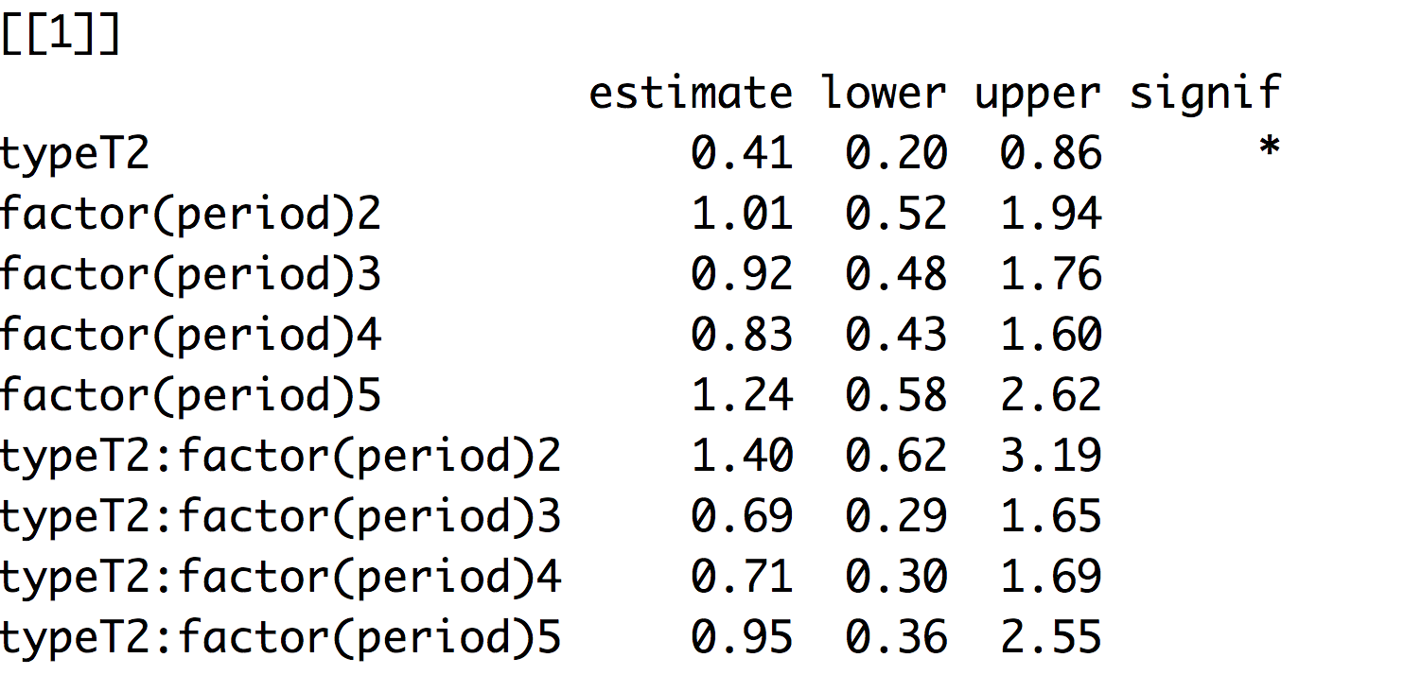

We are 0.4 times as likely to see this cell type in a T2 mouse than in a WT mouse. There is no significant difference in time response. We have similar results in CD19, CD19posB220posMHCII.

**4. CD11c**

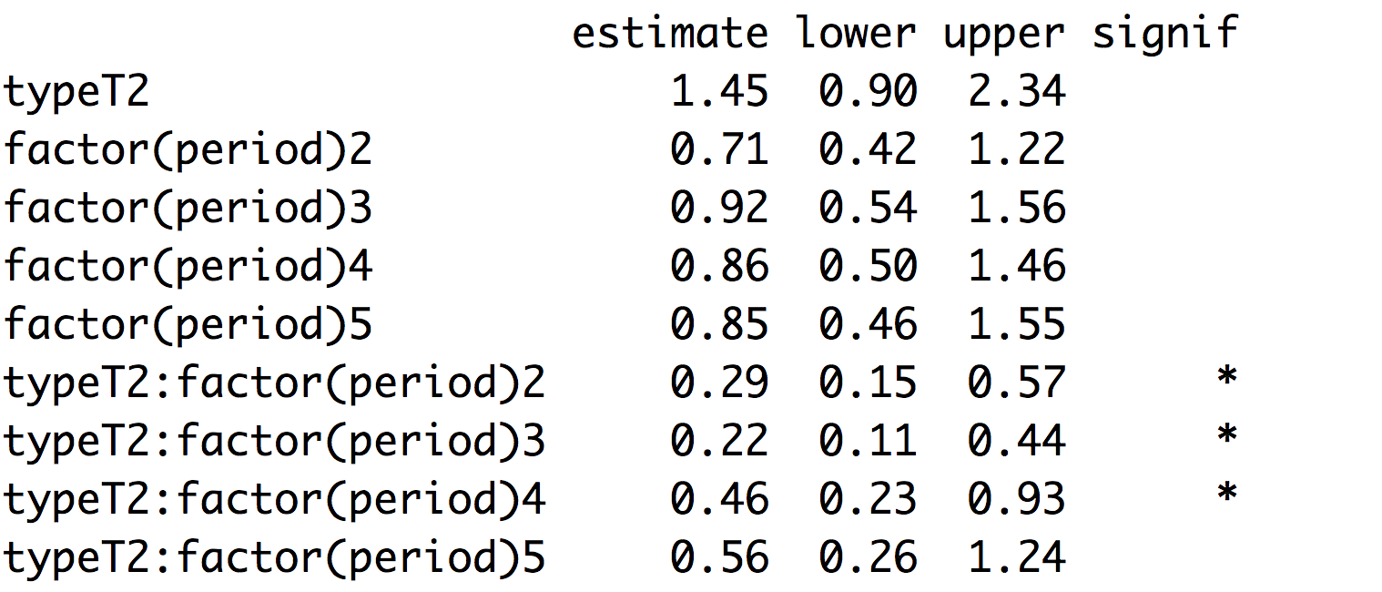

We are 0.3 times as likely to see this type of cell at time 2,3 and 4 (days 3,10, 17) for WT mice, compared to T2 mice. By day 24, there is no difference. This is precisely the response we were looking for.

## CD19posb20

Should I base my analysis on all mice, or just on the male mice? Are male and female mice so different, in regard to how the cell counts change over time, that I am best leaving out the females?

I fitted this model:

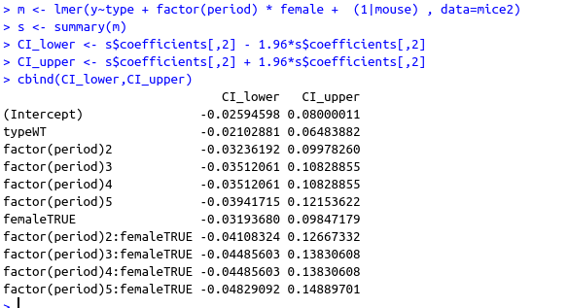

female is significant, as are the interactions with time.

It seems to me that females and males are really quite different, in how to respond over time, so I am going to leave the females out of the analysis altogether. I will have to check that again for other cell types.

WT mice are black, Pound mice are red.

**Wild type**

**Day0 3 10 17 24**

6 0.18 0.21 0.24 0.22 0.3

7 0.26 0.21 0.21 0.13 0.21

23 0.22 0.23 0.15 0.21 NA

24 0.18

**Pound (T2)**

8 0.14 0.22 0.26 0.13 0.13

9 NA 0.25 0.08 0.07 0.14

10 0.17

19 0.05 0.11 0.02 0.05 0.12

20 0.12 0.1 0.05 0.04

21 0.08 0.12

22 0.05 0.05

We have 38 observations on 11 mice, over 5 time periods.

We are not longing for a linear trend, but the hypothesis is that the Pound mice show a reduction in cell after t=0, and then revert to their pre-stroke level.

Let’s start by treating the proportions as Gaussian (i.e. Normal). Of course, this cannot be correct, because proportions are in the range from zero to one, but we can disregard that for now.

To start with, we can do **t-tests** at time=0,3,10,17,24:

In summary:

|  |  |  |  |  |  |
| --- | --- | --- | --- | --- | --- |
| **Period** | **95% CI for difference** | **p-value** |  | N WT | N Pound |
| 1: day 0 | 0.17;0.04 | 0.01 | ** | 4 | 6 |
| 2:day 3 | -0.15;0.01 | 0.07 | * | 3 | 6 |
| 3:day 10 | -0.25; 0.06 | 0.16 |  | 3 | 4 |
| 4:day 17 | 0.21;0.02 | 0.03 | * | 3 | 4 |
| 5:day 24 | -0.70; 0.46 | 0.23 |  | 2 | 3 |

So at alpha=0.05, the means are different at day 0 and 17, but not thereafter. At alpha=0.10, the means are also different at day 3. In those cases, Pound mice are lower, on average by between approximately 0 and 20%.

We can also do *paired* t-tests (to account for correlation within mice over time), comparing individual mice at each period (i.e. comparing with period 1), separately for each type of mouse (WT or Pound). We get very high p-values, suggesting no evidence for difference over time, for both types.

Next, we fit a mixed model, with main effects type (WT, Pound) , sex, and time period (factor with levels 1,2,3,4,5) and a random intercept for each mouse. Our interest is in the interaction between time and type, because this will tell us whether the effect of time differs by type.

I have removed the PLT mice from the dataset, because we are not intested in them, and we suspect they are very different from the Pound mice, in which we are interested. First, I fit a model, which includes sex and a sex x time interaction. The results suggest that the sex x time interaction is significant. So girl mice and boy mice behave differently over time. Since our interest is in the male mice, I decided to leave the female mice out of the dataset, and proceeded with the male mice only.

So in R, I fitted this model:



And these are the **90**% Wald confidence intervals:

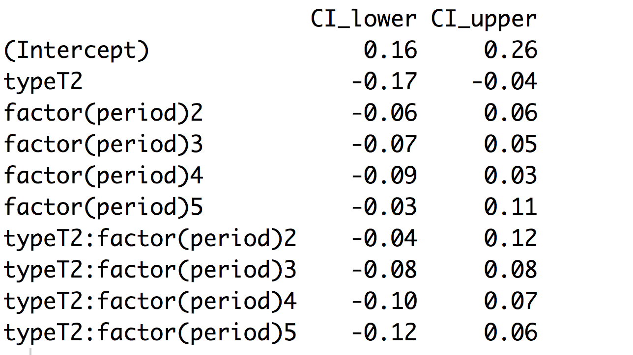

**95% Wald Confidence intervals**

We see that Pound mice (also referred to as T2 mice) are on average lower by between [0.17 to 0.04] (ie. 17 to 4 percentage points) than WT mice. There is no relationship between time and type, so we have no evidence for our hypothesis: WT mice cell counts decrease after stroke, and then revert to their pre-stroke level.

I have also fitted a model with stroke_size (scaled) as a covariate, but this turned out to be insignificant, and I dropped it from the model.

Let’s check our model assumptions. First, my favourite: The police line-up method: Here is plot of 9 sets of residuals simulated from the model, and 1 plot with the real residuals.

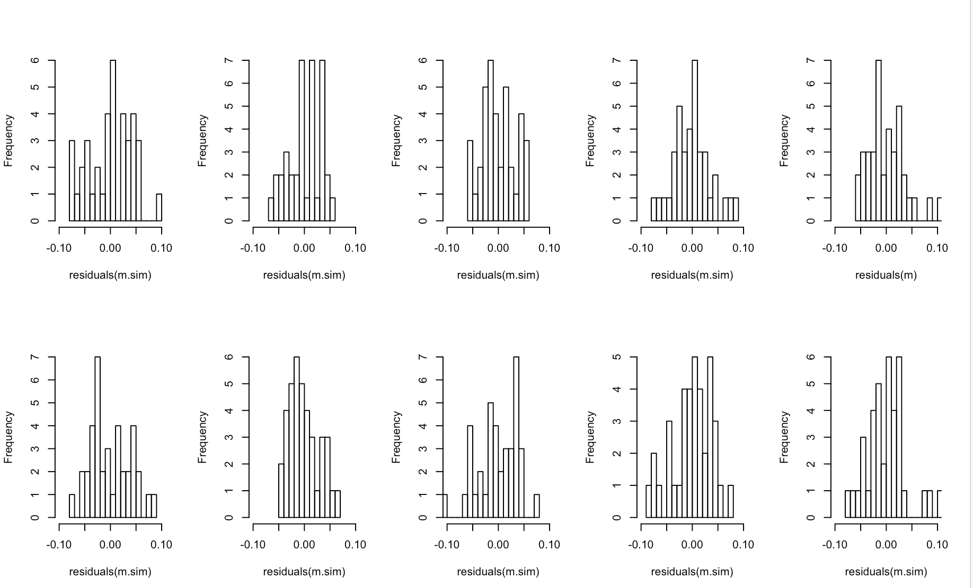

The reader has to guess which plot is the odd one out, and a correct guess shows poor adherence to assumptions. I guessed wrong, so – with N=1- the model does not appear to do to badly. To check your answer, translate the word ‘bost’ from the Basque language.

Residual plots don’t reveal any interesting patterns:

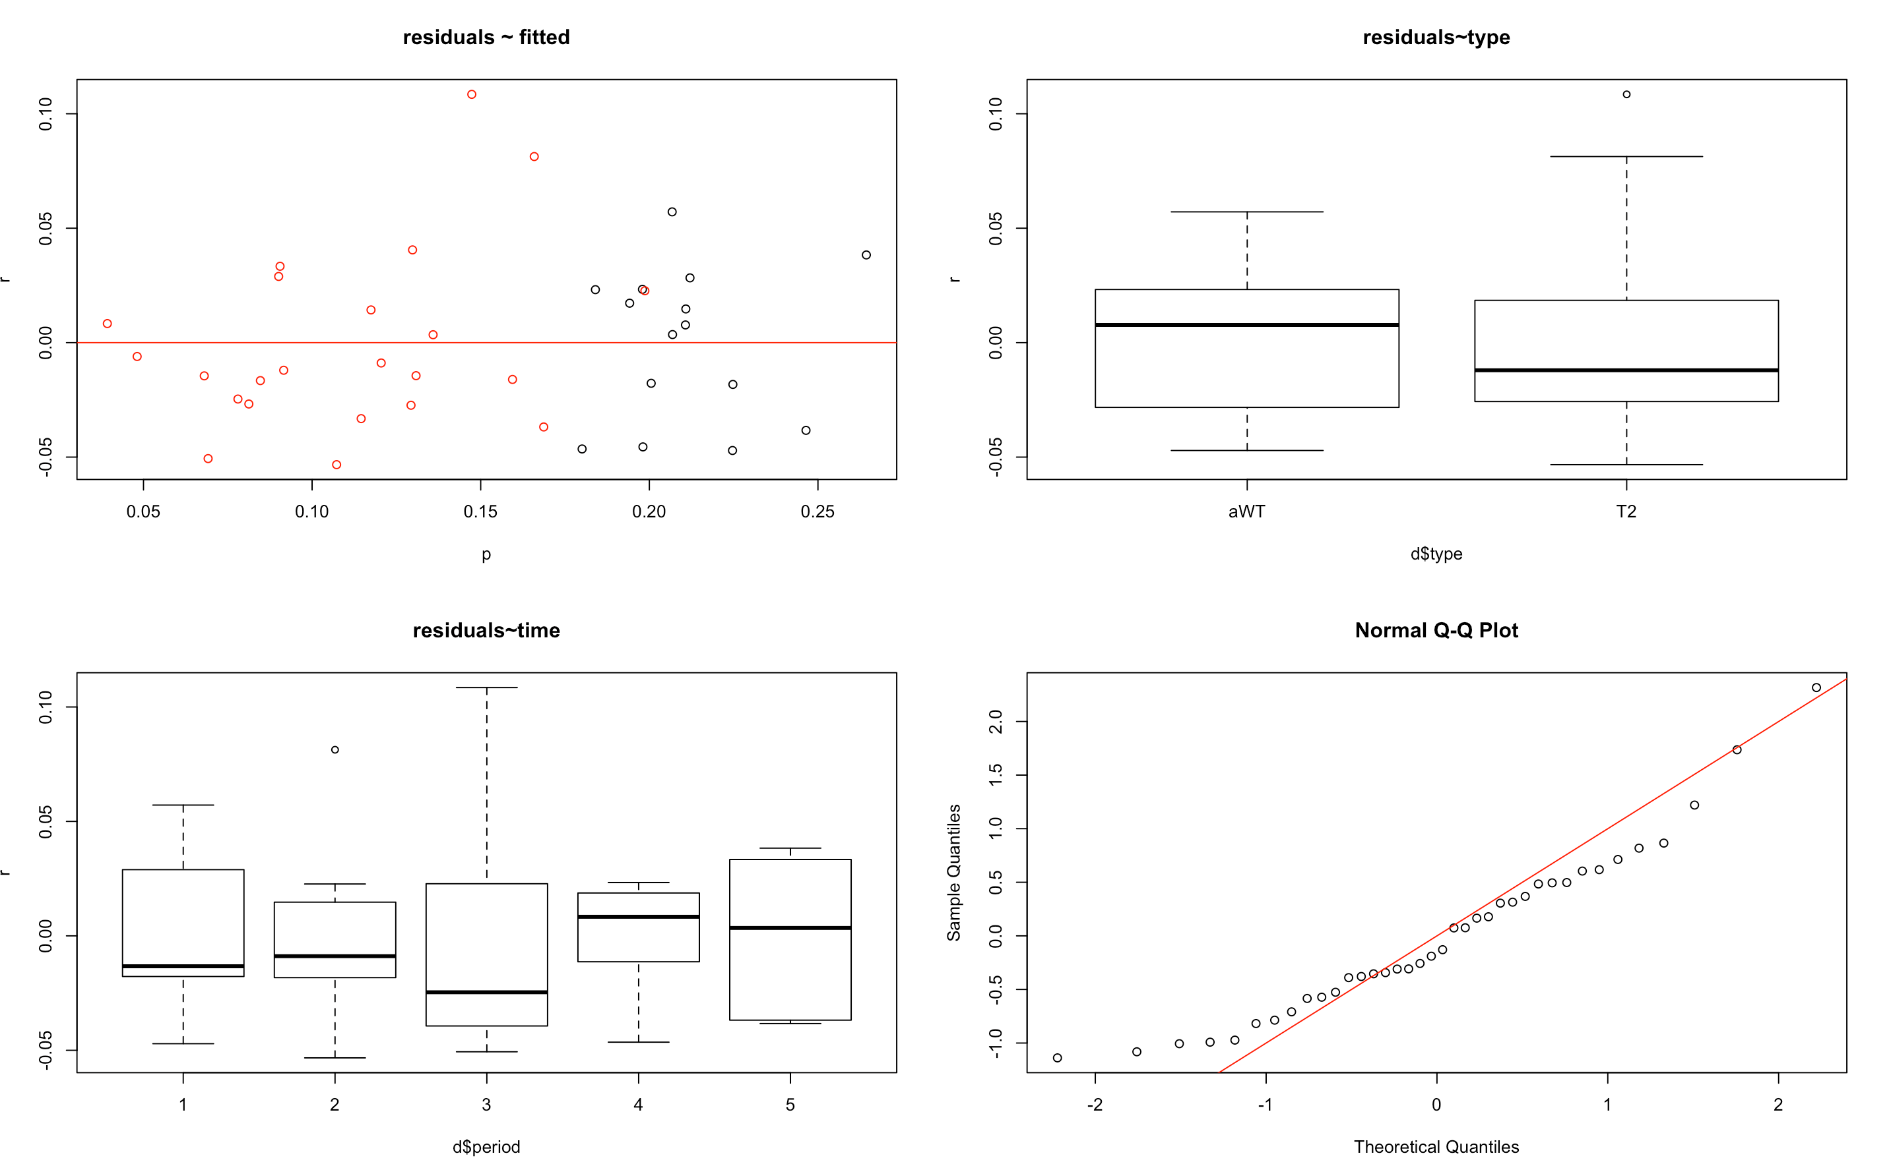

The Q-Q plot, however, shows that the residuals are not on the red line, and they are not normally distributed, particularly towards the extremes. This is, I suspect, because the data is limited to the range [0,1], and the model has no such restriction.

Here we have fitted vs. Observed: The model never fits outside the range [0,1], which is good. This looks pretty good, I think.

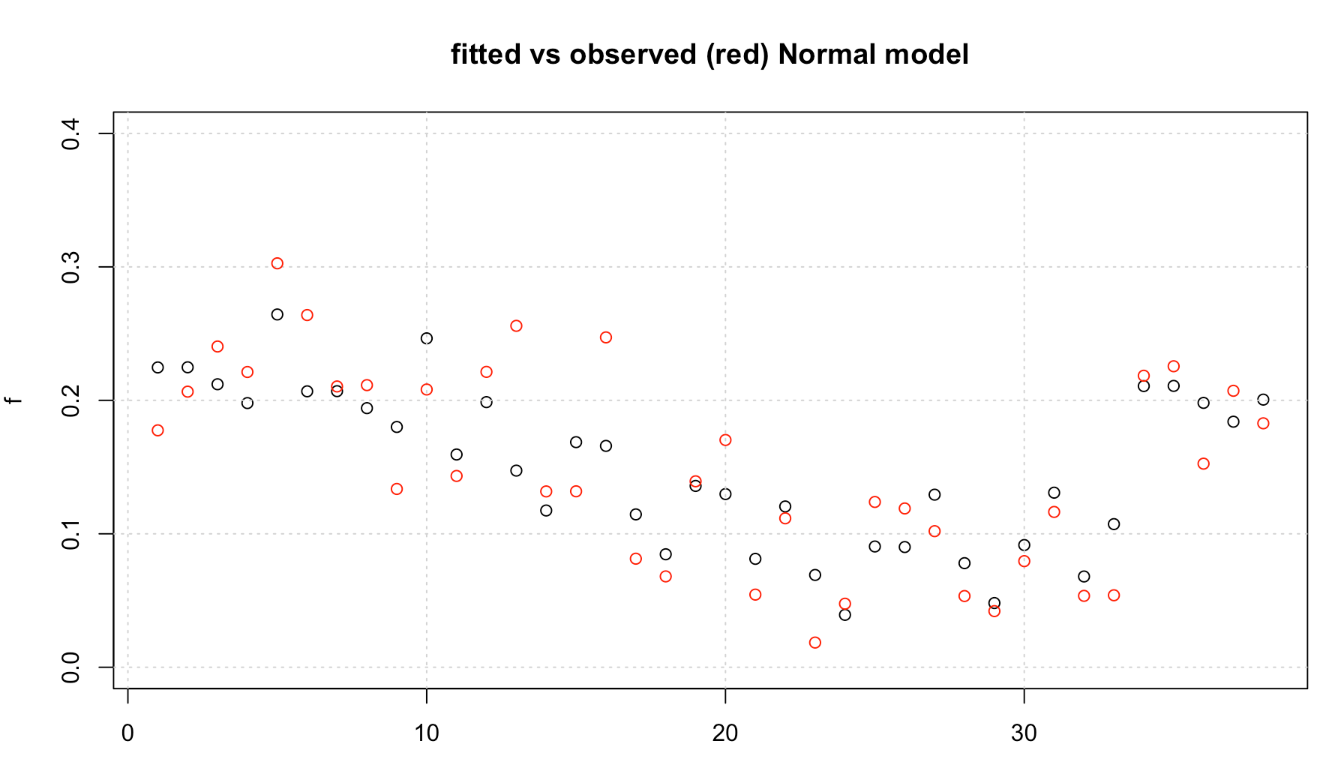

We can also fit a beta-regression model, which has the property that the dependent variable is in the range [0,1].

In R, we fit:

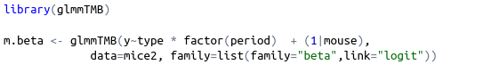

Here are the coefficients:

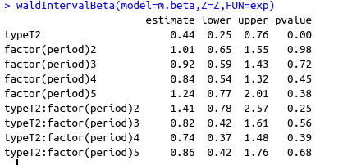

The confidence intervals are now for odds ratios. All except type includes the value 1, so they are not significant. This tells us that, on average, the odds of seeing a T2 (Pound) cell are about half those of a WT cell. That means T2 cells are present, on average, at numbers between 20%-40% of WT cells.

Again, the police lineup method.

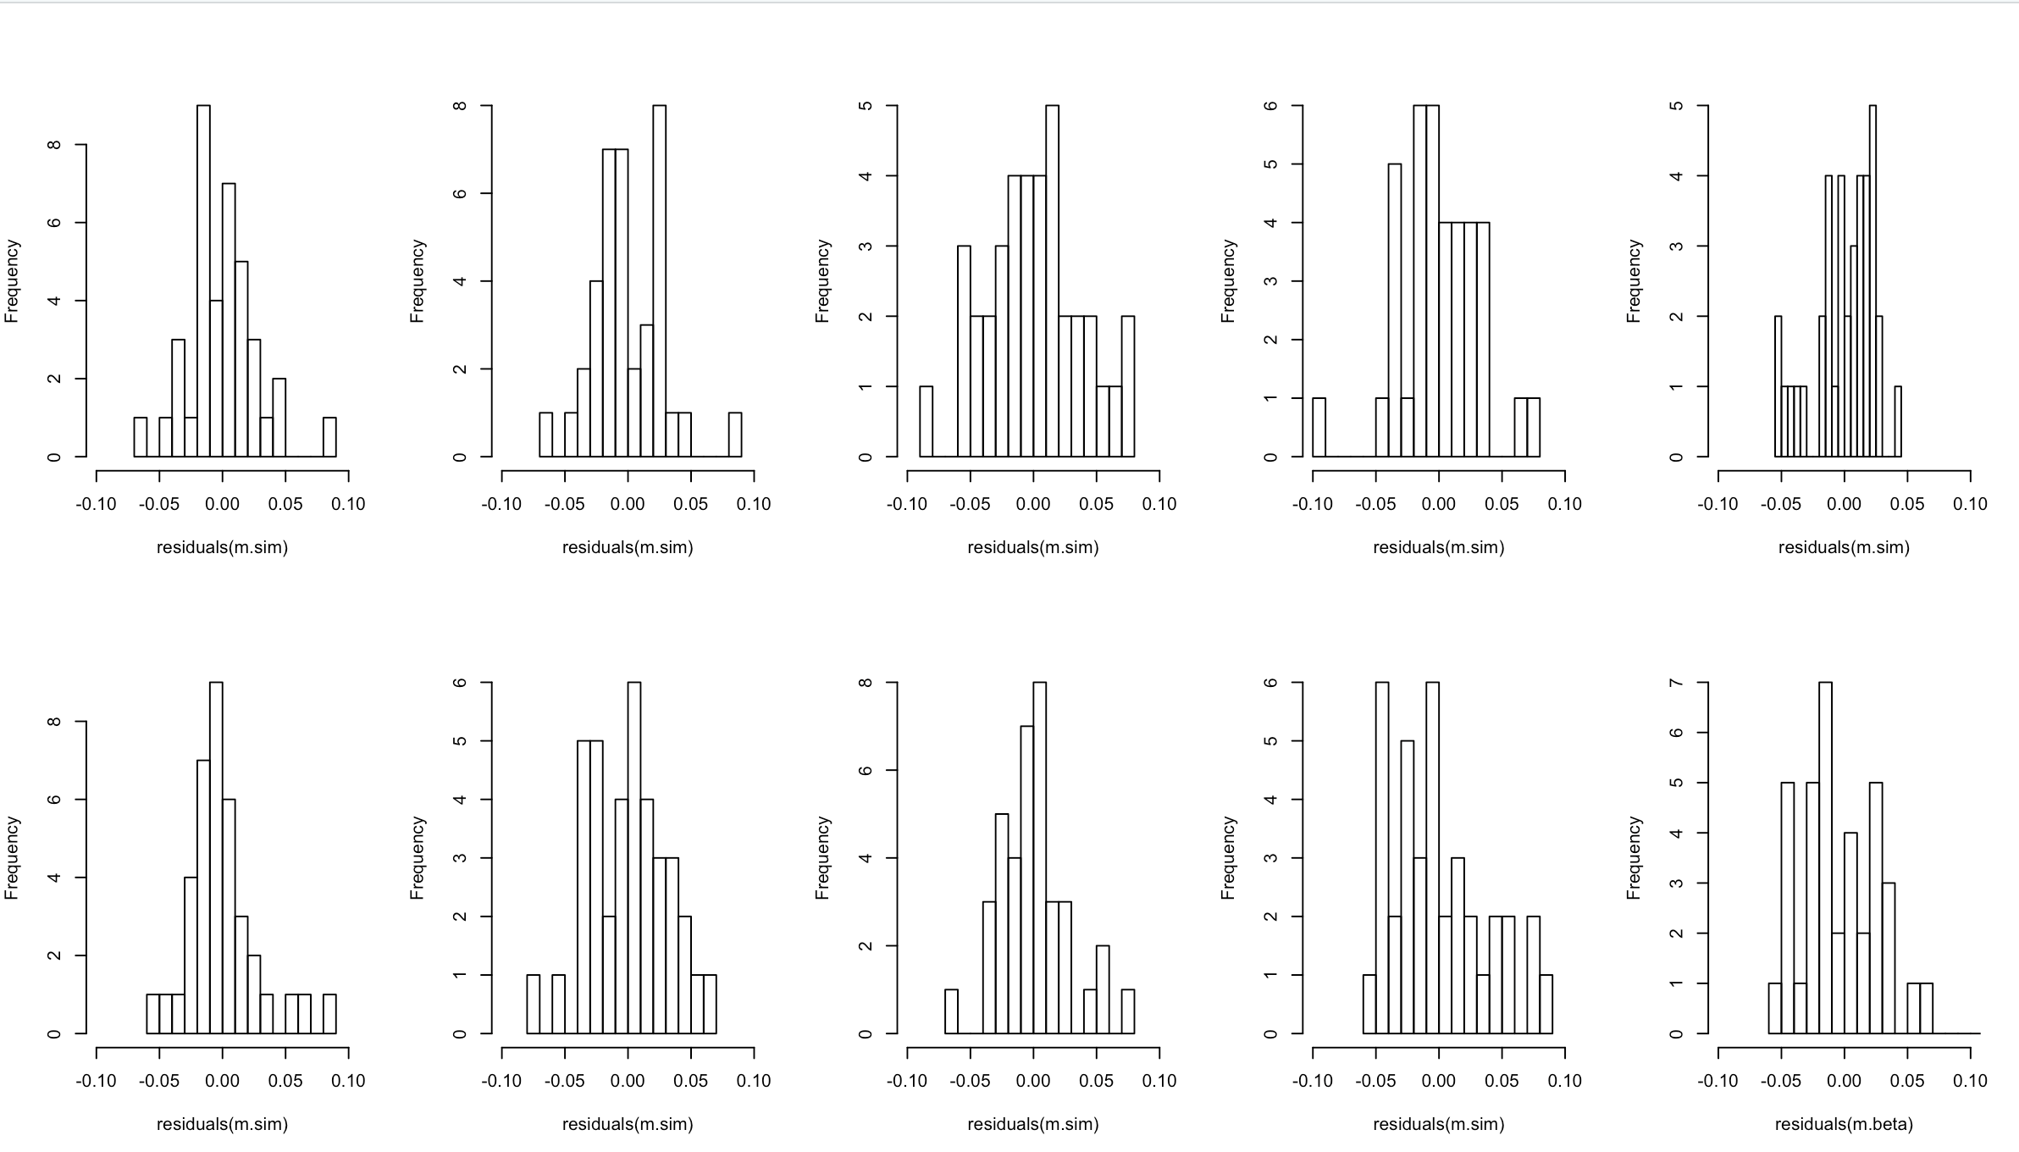

A Basque person would say the he true residuals are in plot # hamar. I did not guess that.

Here are plots of residuals ~ fitted; residuals ~ type; residuals~ time:

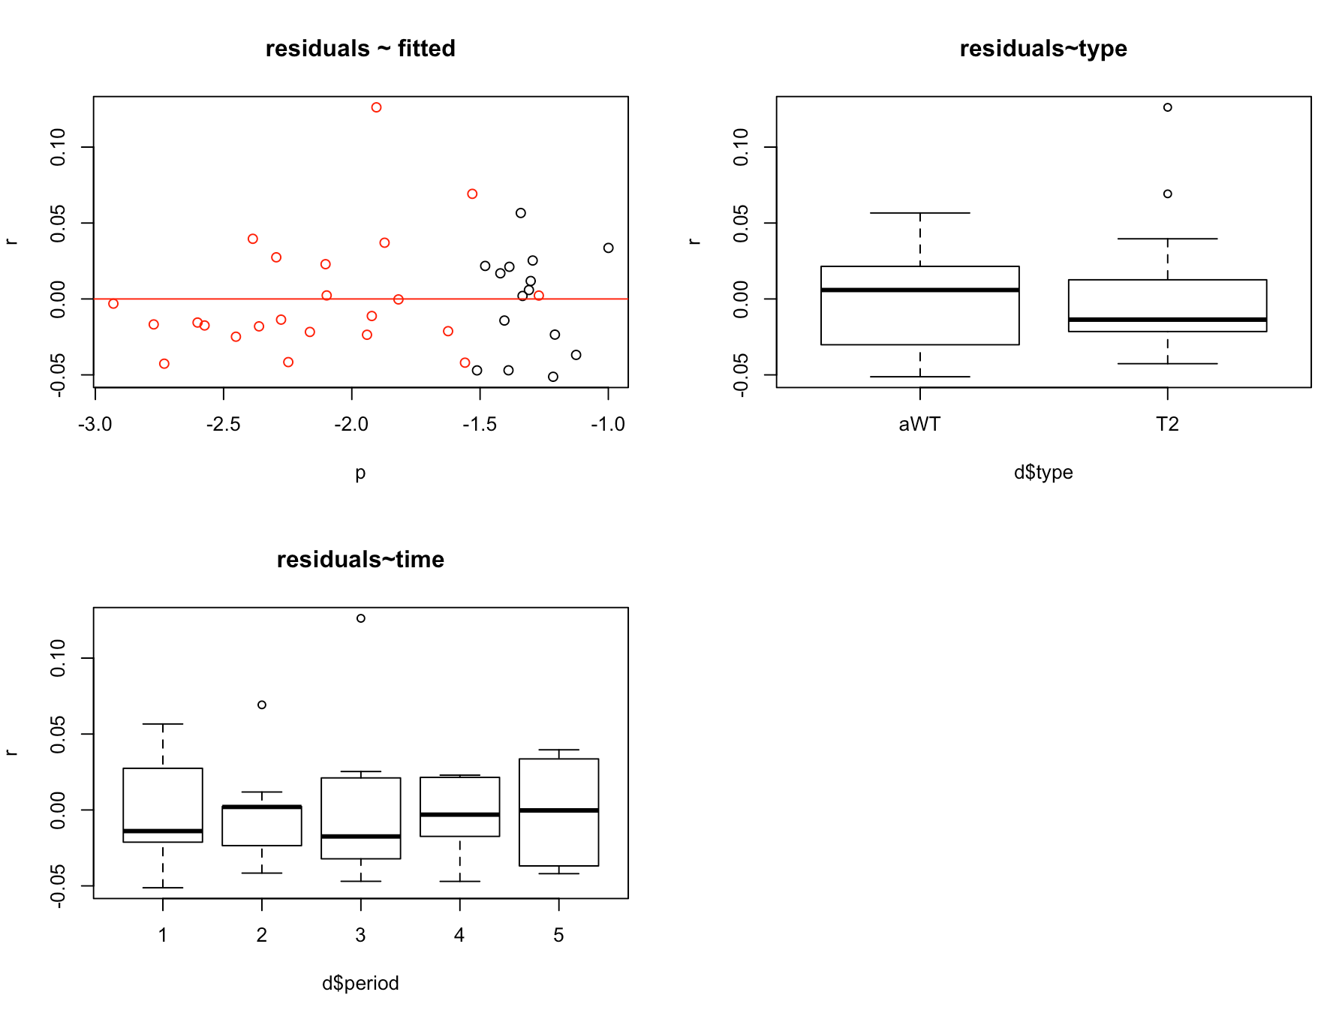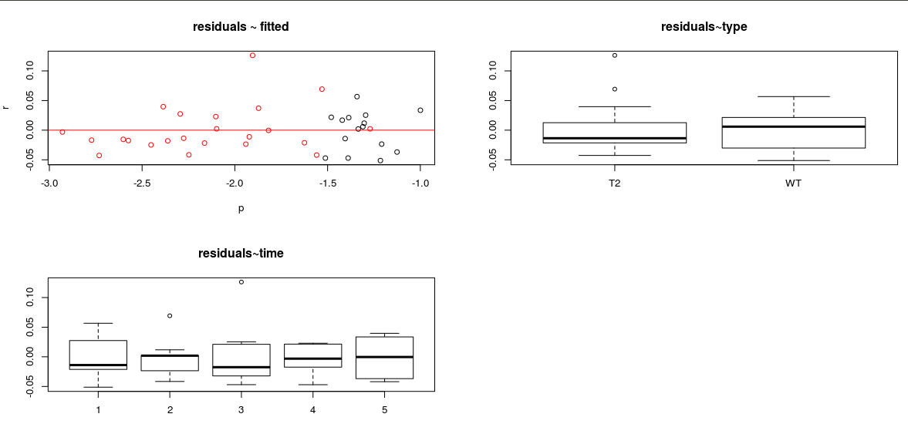

The observed vs. Fitted plot is almost identical to the one we saw for the Normal model.

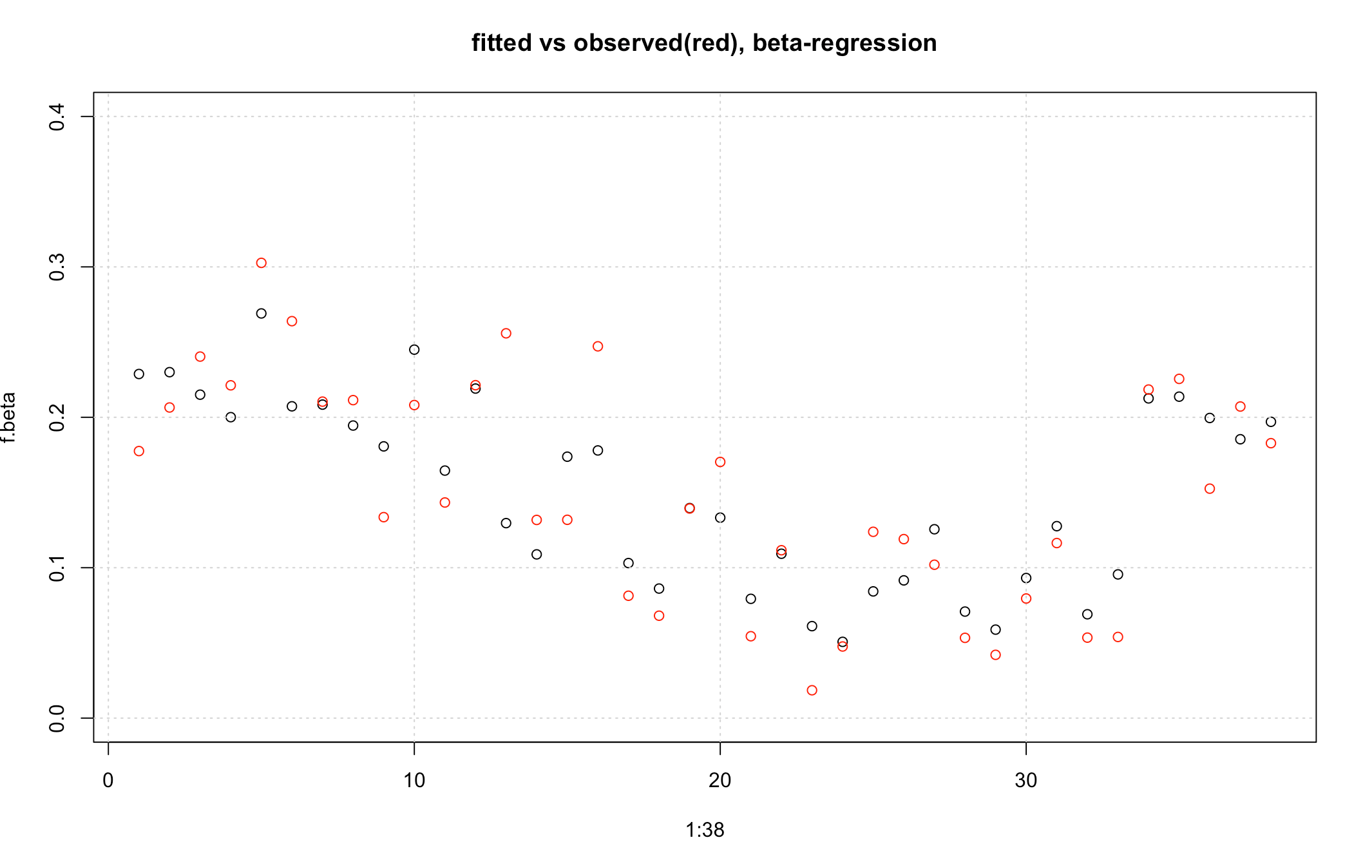

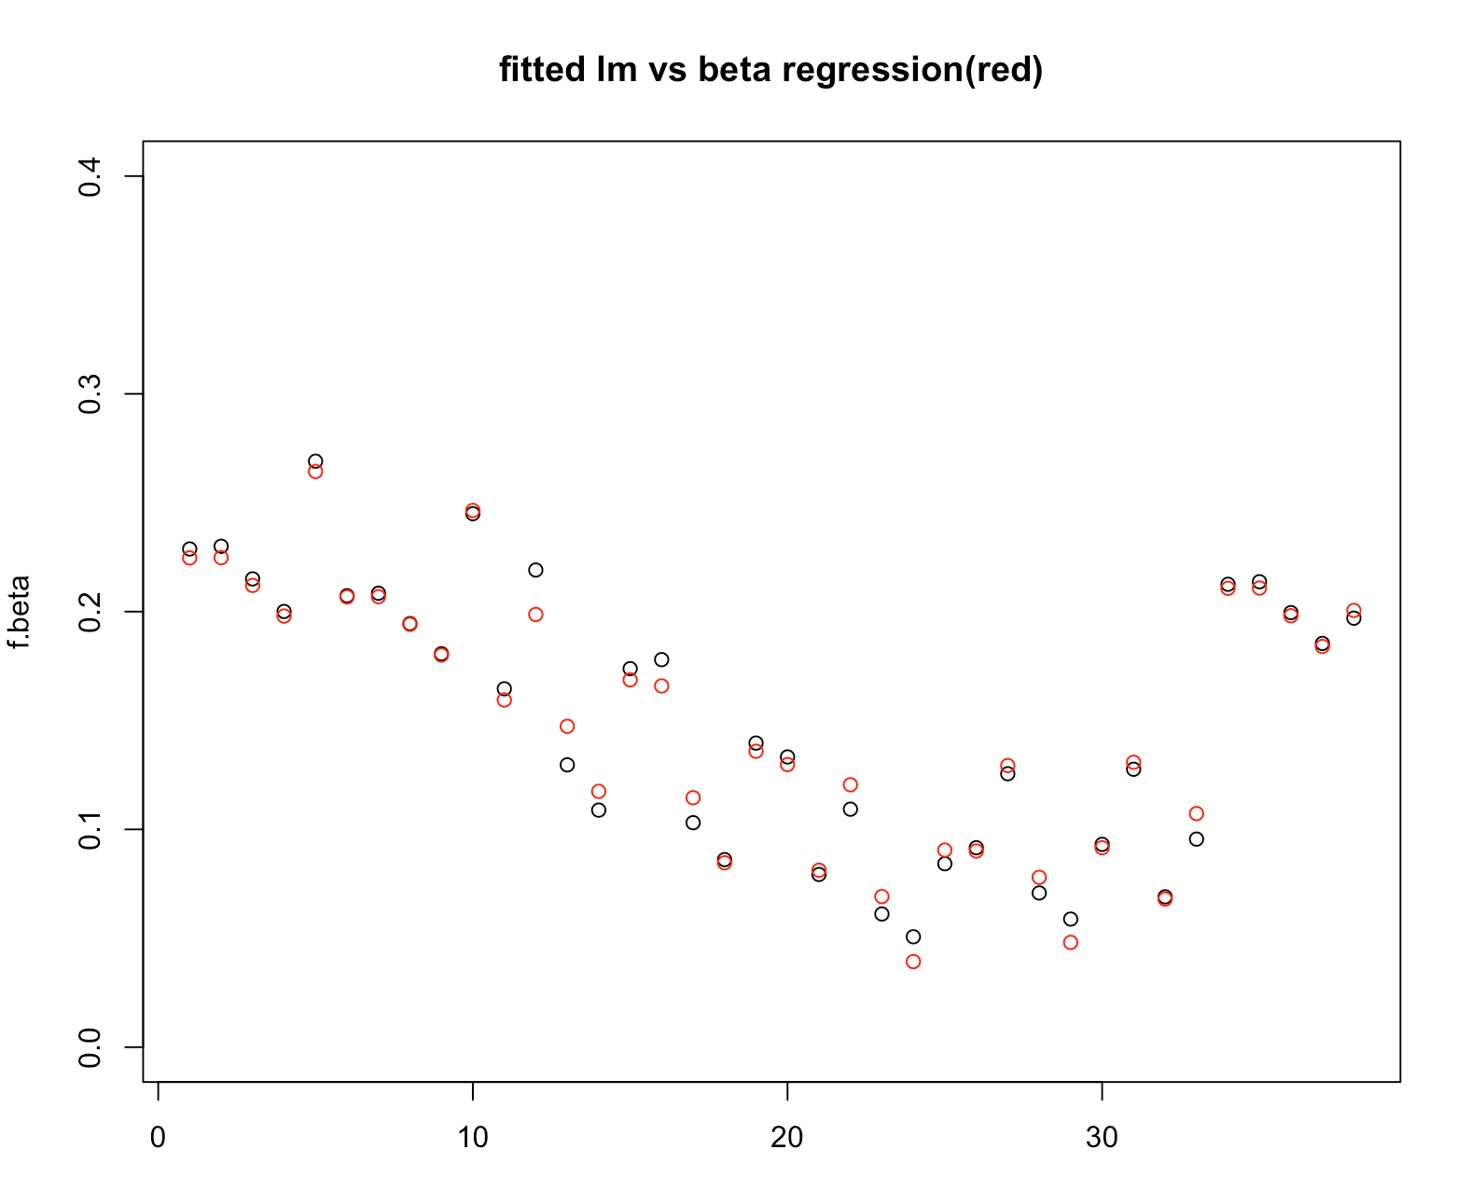

We can also transform the cell proportions (the dependent variable) with the logit function, to get it on the real [-inf,+inf] scale.

This results in fairly similar fitted values:

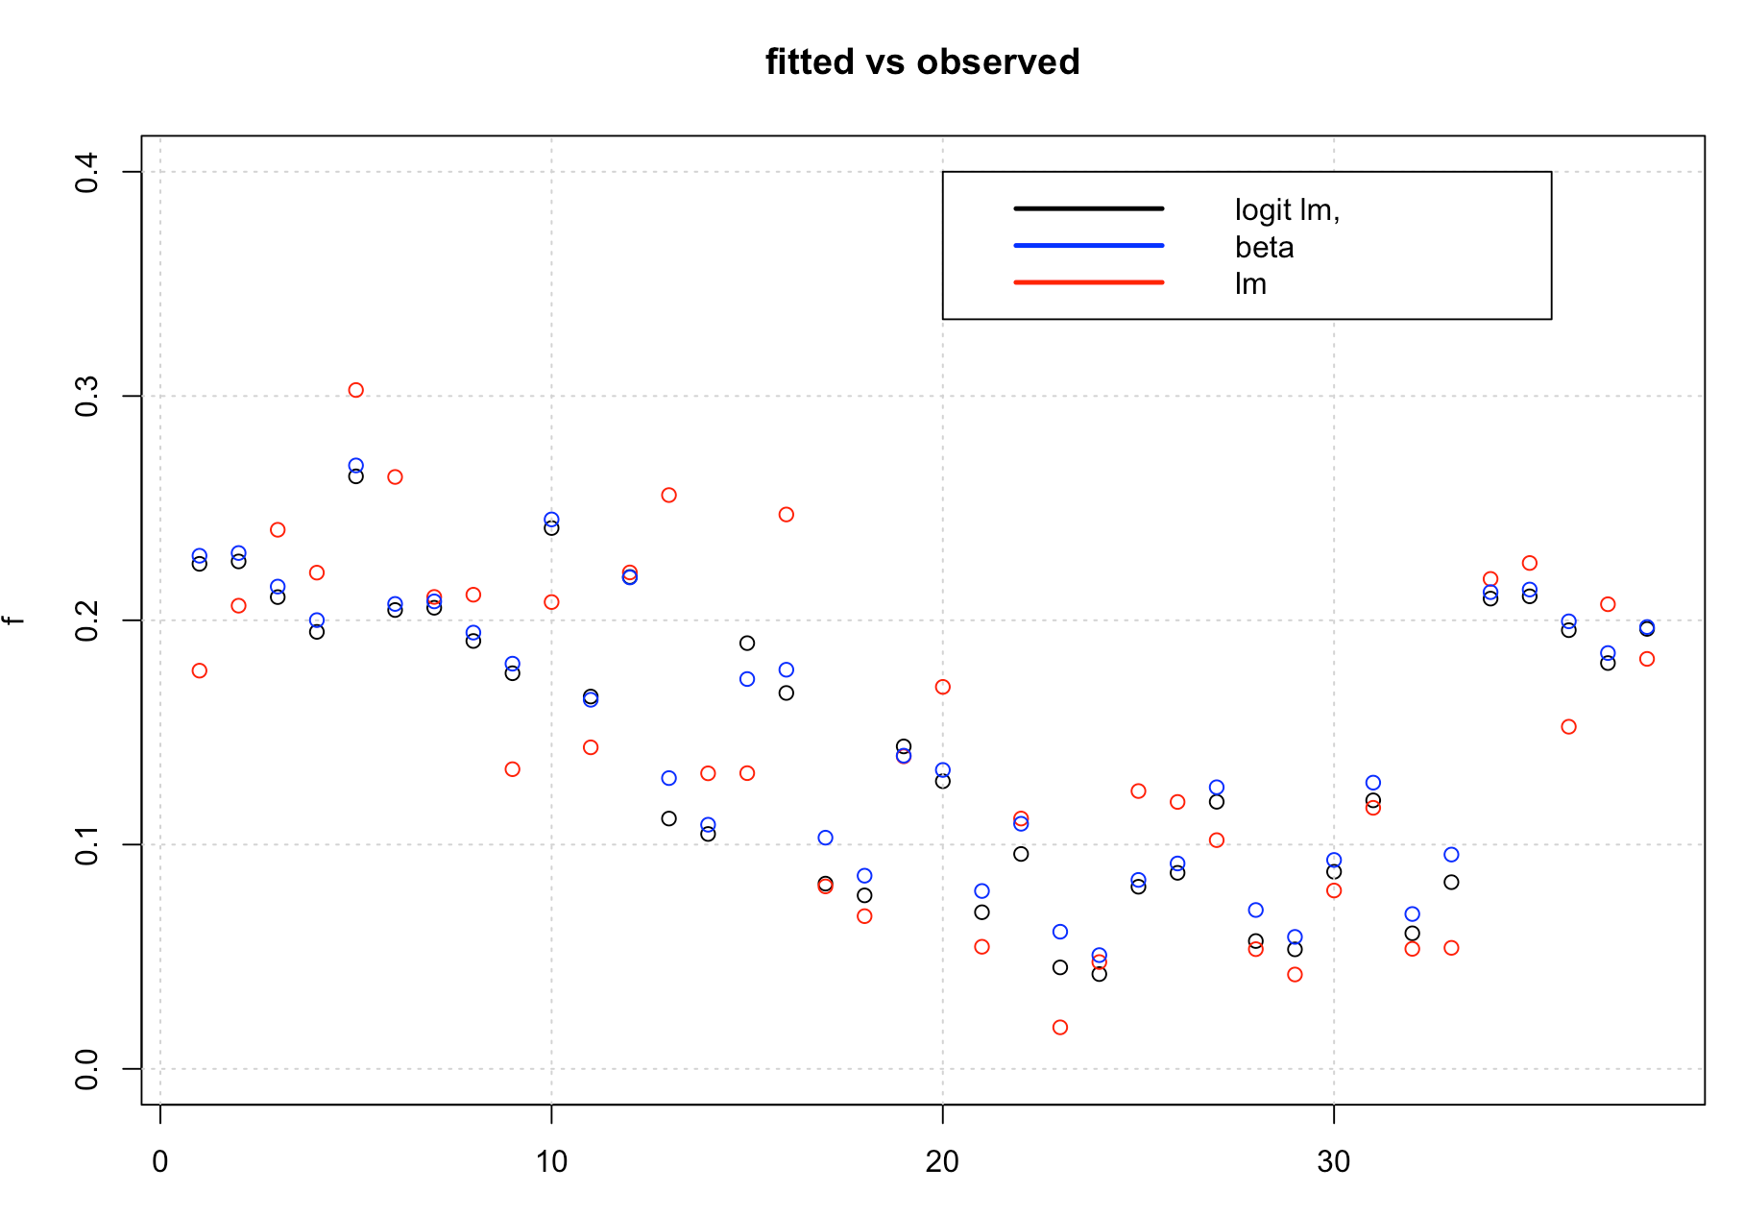

The confidence intervals are now odds ratios:

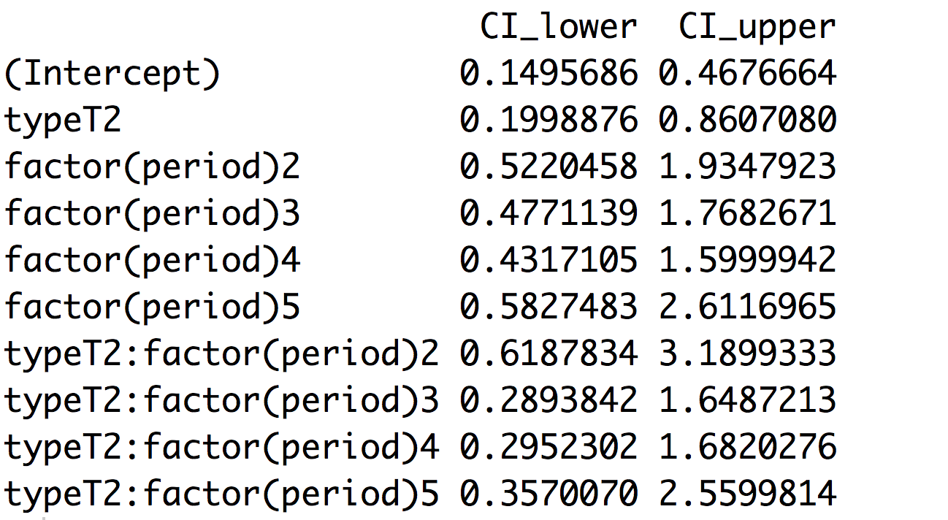

All include the value 1, with the exception of typeT2, which is what we found before.

Here are the residual plots:

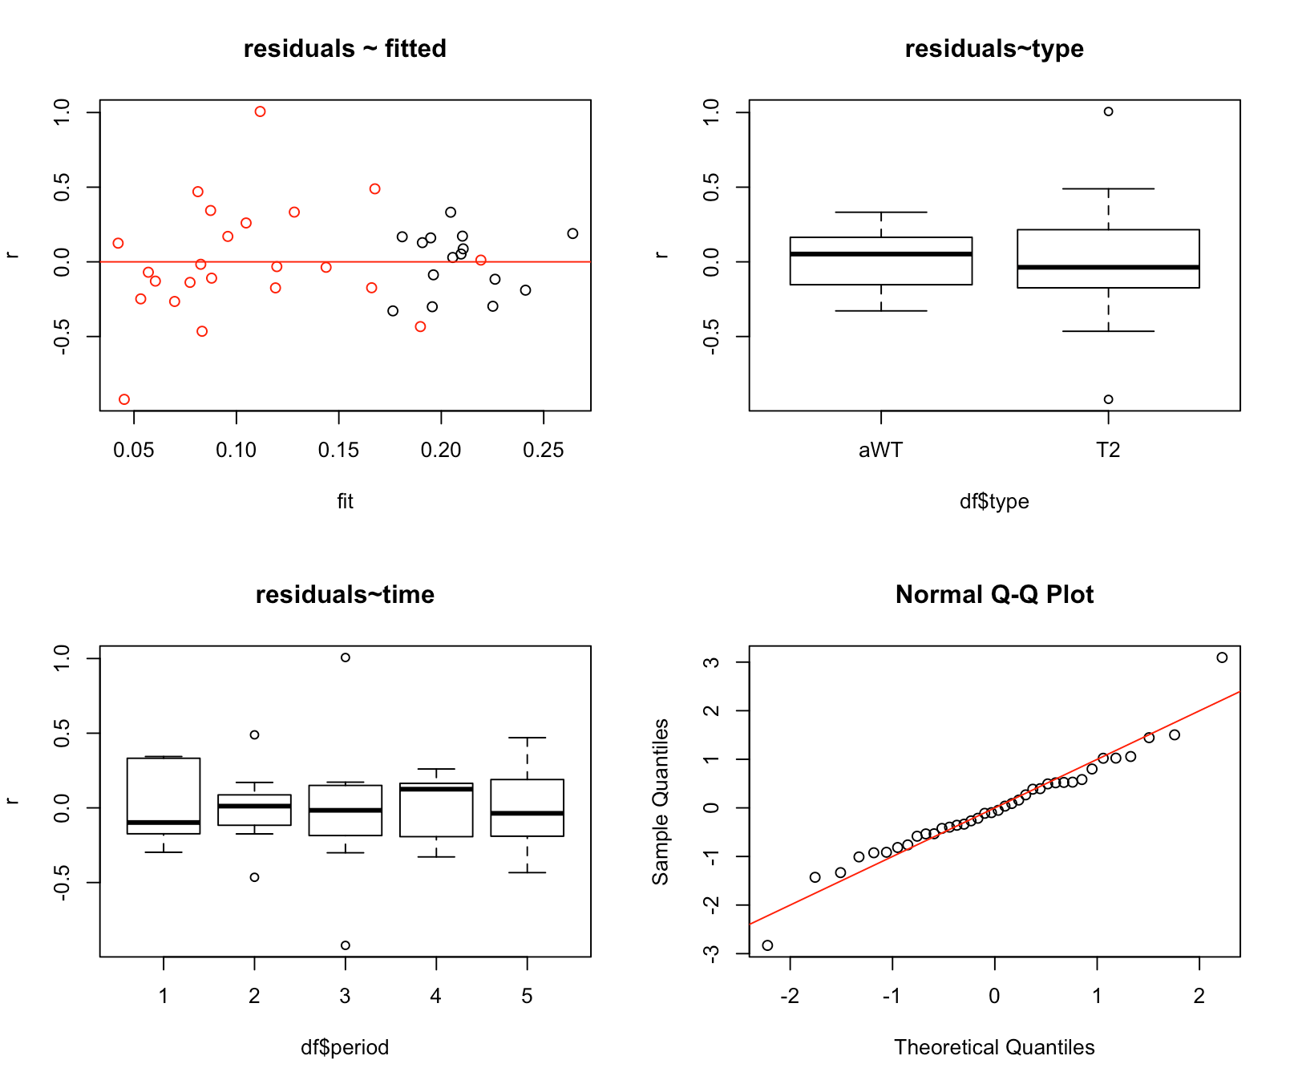

Perhaps a little better than what we saw before.

For all three models, I have also looked at the auto-correlation of the residuals. They are similar across models. Here is the one for the logistic model:

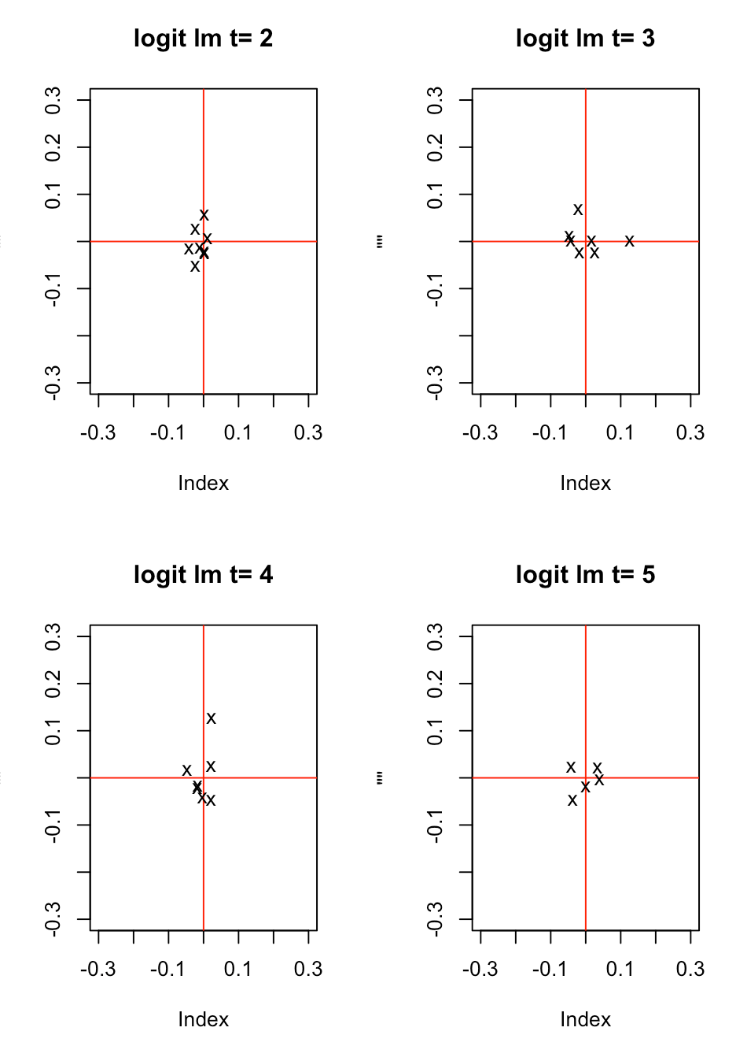

Each cross is for 1 mouse. It shows the residual at time t, plotted against the residual at t-1.

This looks fairly random, showing no sign of a relationship between the residual for a given mouse at time t with time t-1.

Conclusion

All in all, these models seem to behave very alike, and there is not much to choose from. We have no evidence whatsoever that there is a difference between male WT and Pound mice over time, with respect to this cell type. We don’t even have any evidence that stroke does anything at all to cell type CD19pos_B220.s

We now repeat this analysis for the other cell types.

## CD11c

**WT**

**Day0 3 10 17 24**

6 0.02 0.02 0.03 0.02 0.04

7 0.04 0.02 0.03 0.04 0.02

23 0.04 0.04 0.04 0.04

24 0.04

**Pound (T2)**

**Day0 3 10 17 24**

8 0.06 0.01 0.02 0.03 0.02

9 0.02 0.01 0.03 0.03

10 0.07

19 0.07 0.01 0.00 0.02 0.03

20 0.04 0.01 0.01 0.02

21 0.05 0.01

22 0.03 0.01

We have 15 datapoints for 4 WT mice, and 23 datapoints for 7 Pound mice

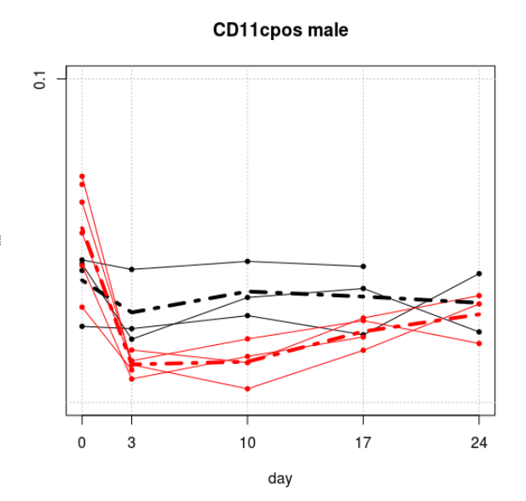

The proportions are all close to zero, and I have fitted a model on the logit scale:

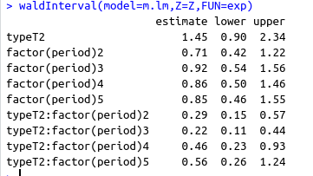

None of the main effects are significant, but the interactions are at day = 3, 10 and 17. This is precisely what we are looking for.

Here are the model predictions for our two types of mice:

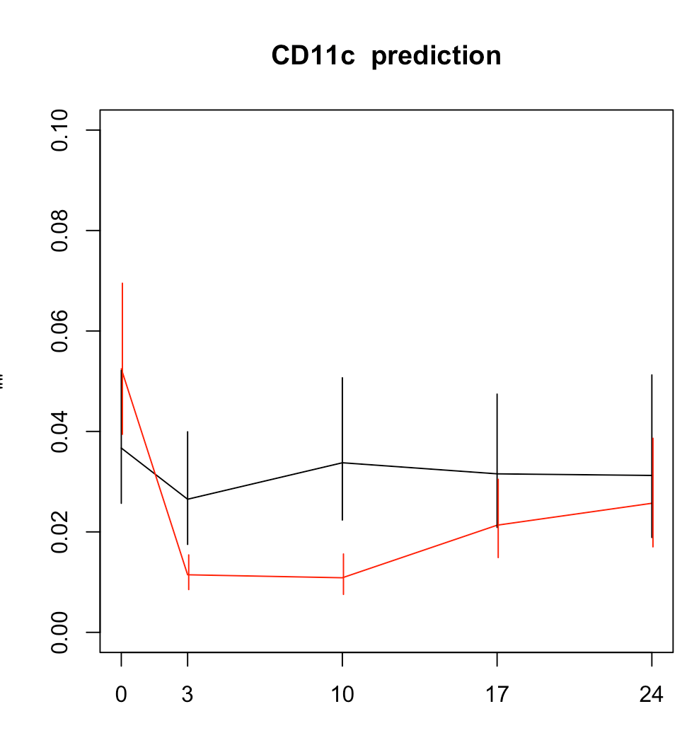

## CD19

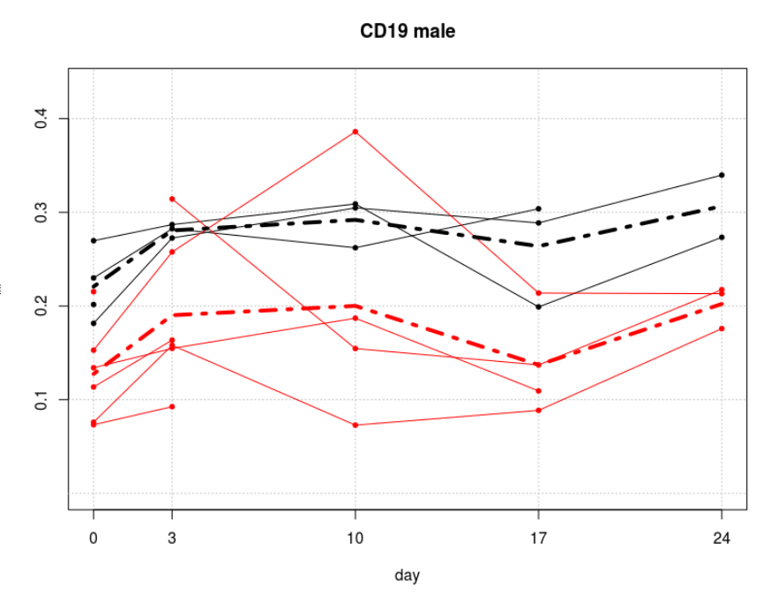

This data is very similar to the first one:

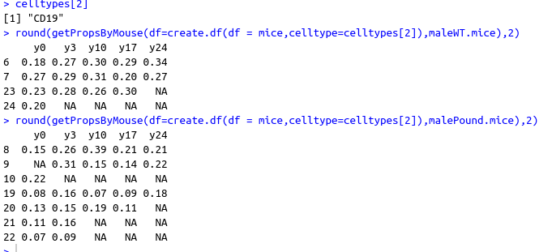

16 observations for WT mice

23 observations for Pound mice

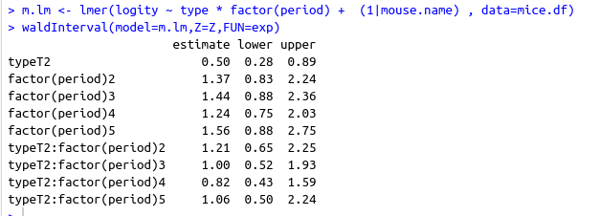

Nothing is signicant beyond typeT2.

## CD19pos_B220pos_MHCII

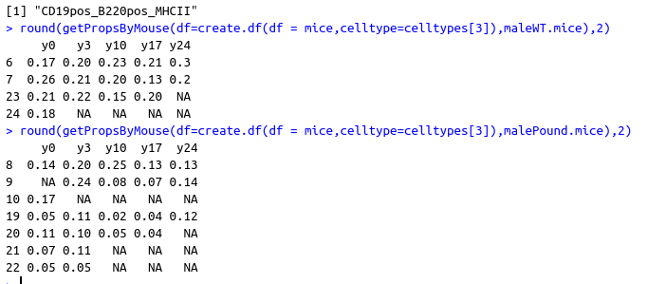

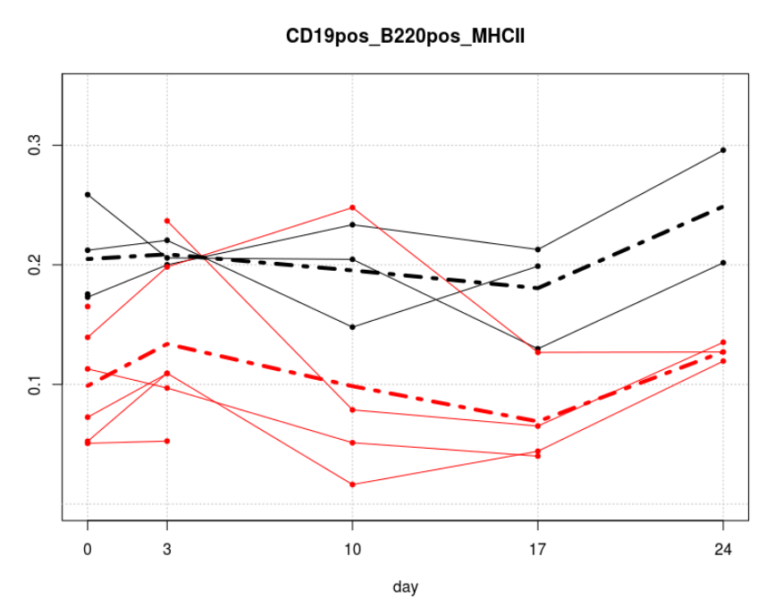

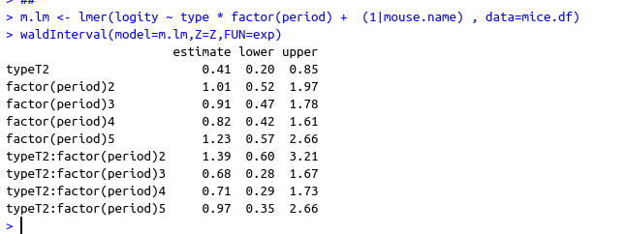

Nothing is significant, except T2

## CD11b

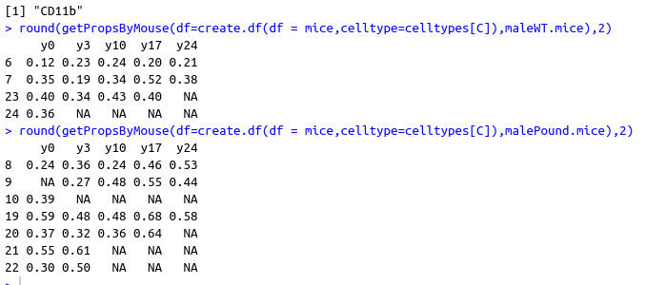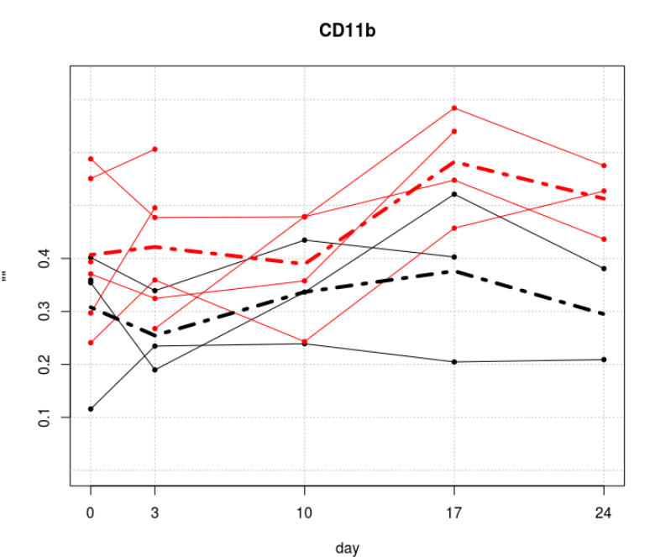

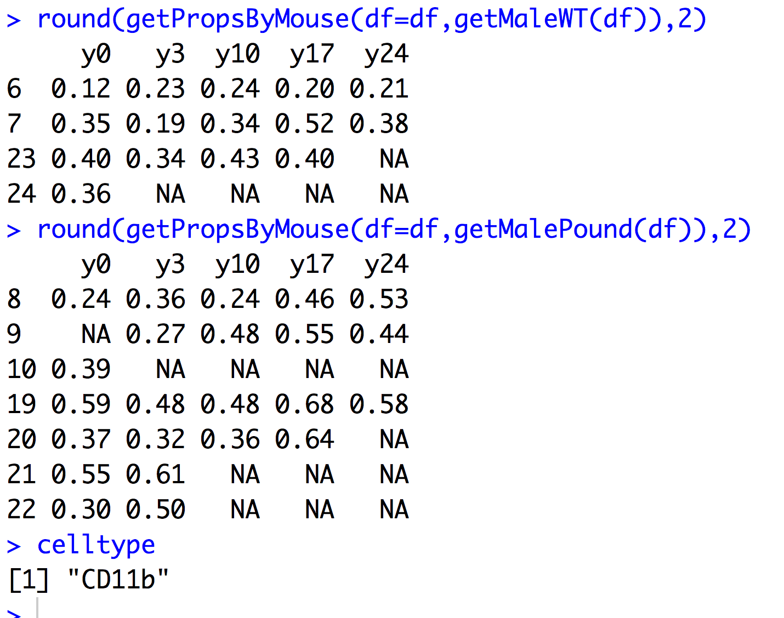

T2 and period2 are lower. Nothing else

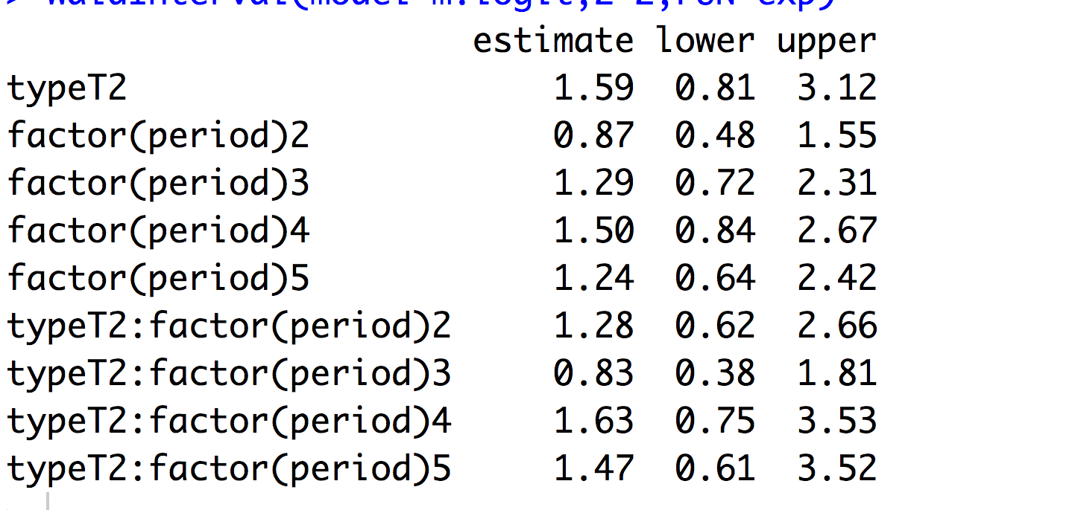

## mMDSCs

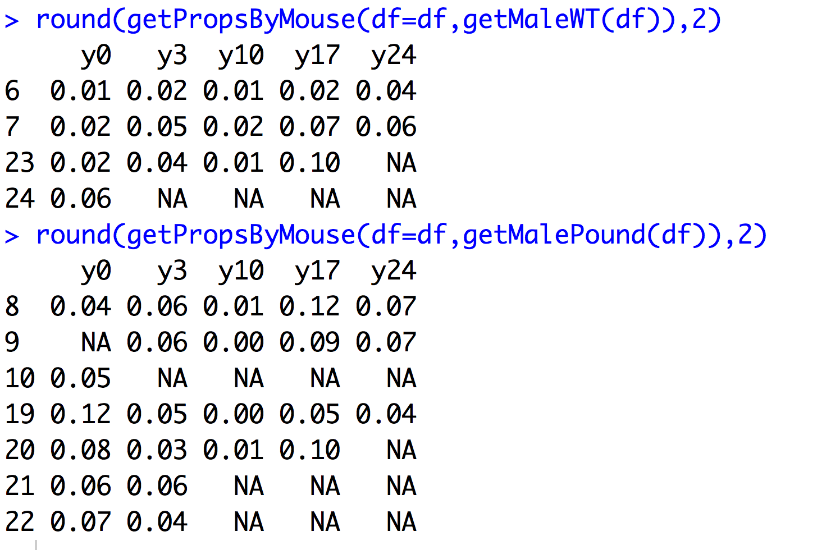

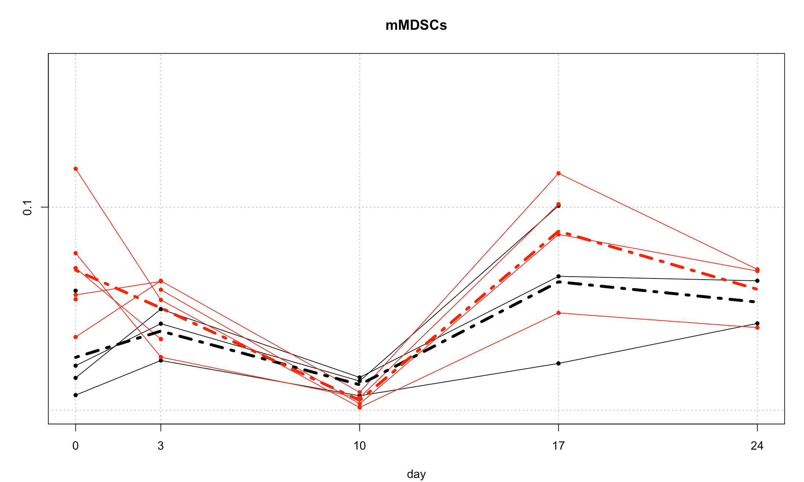

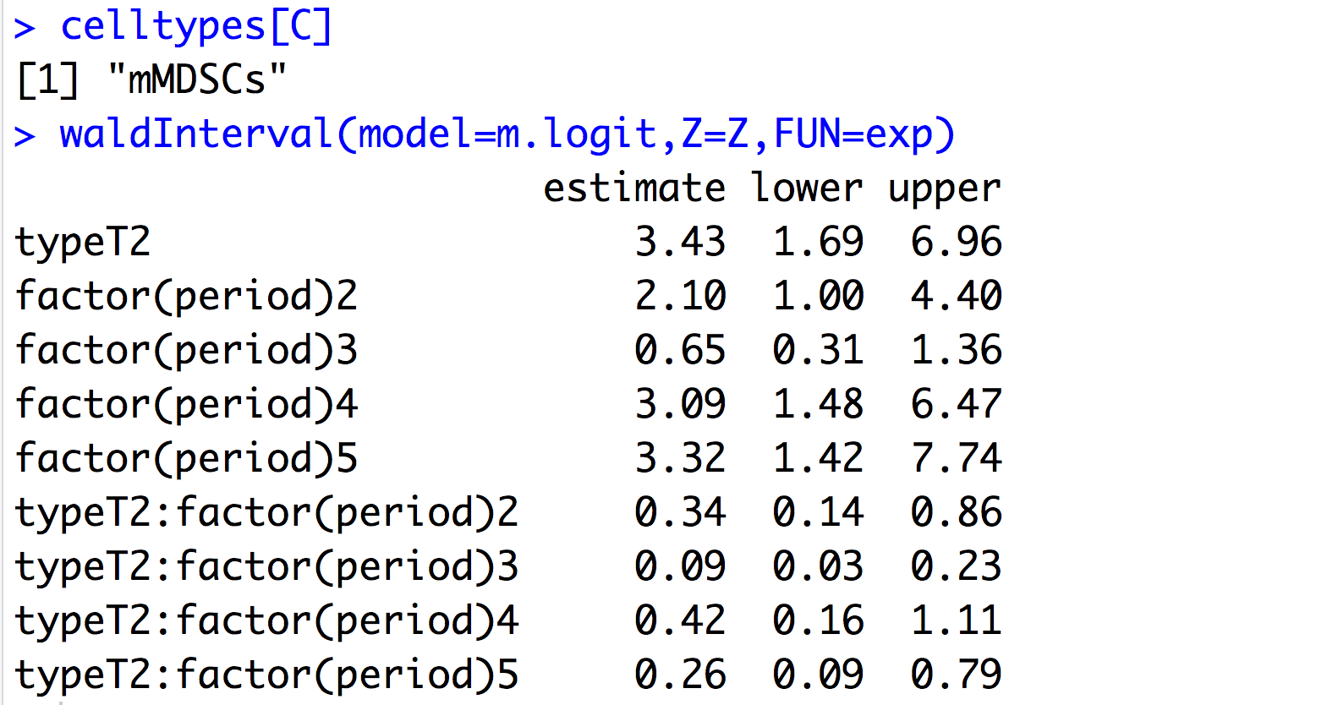

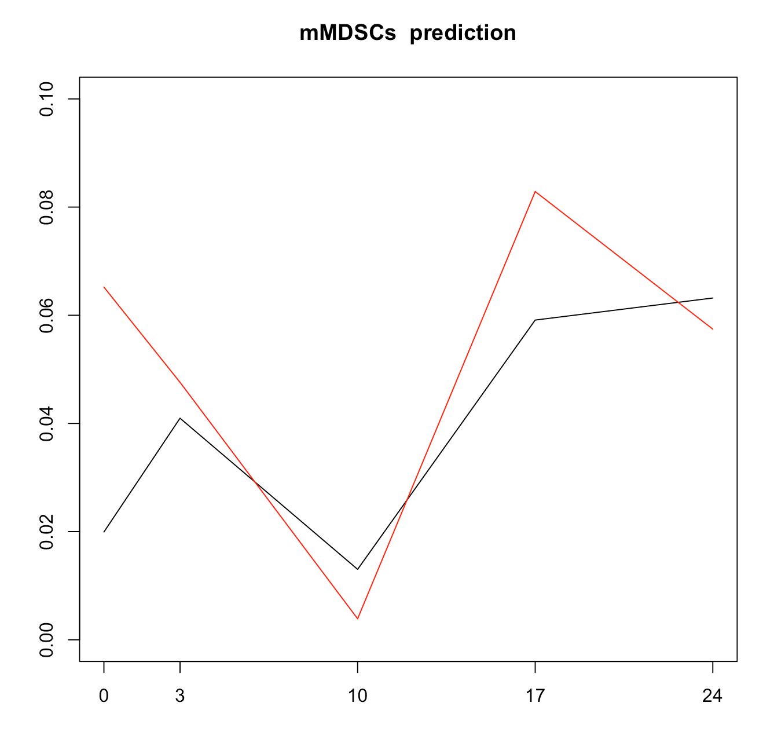

T2 mice are higher than WT mice

All periods except t3 (day 10) are higher than day 0, but less so for T2 mice.

## gMDSCs

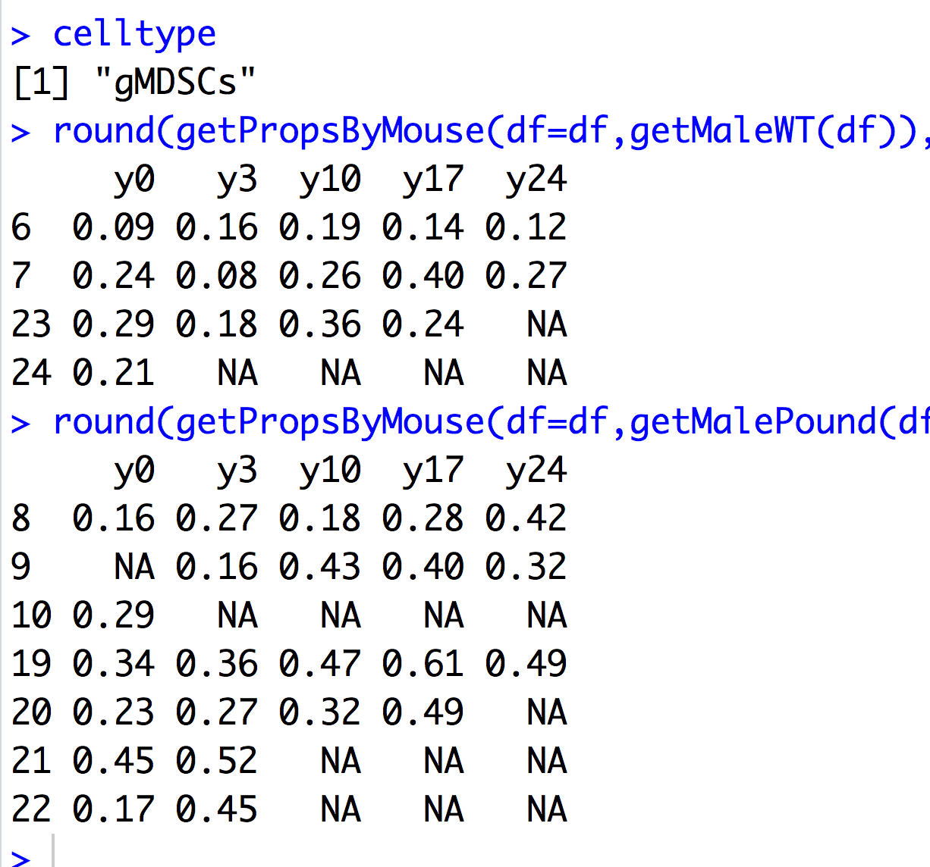

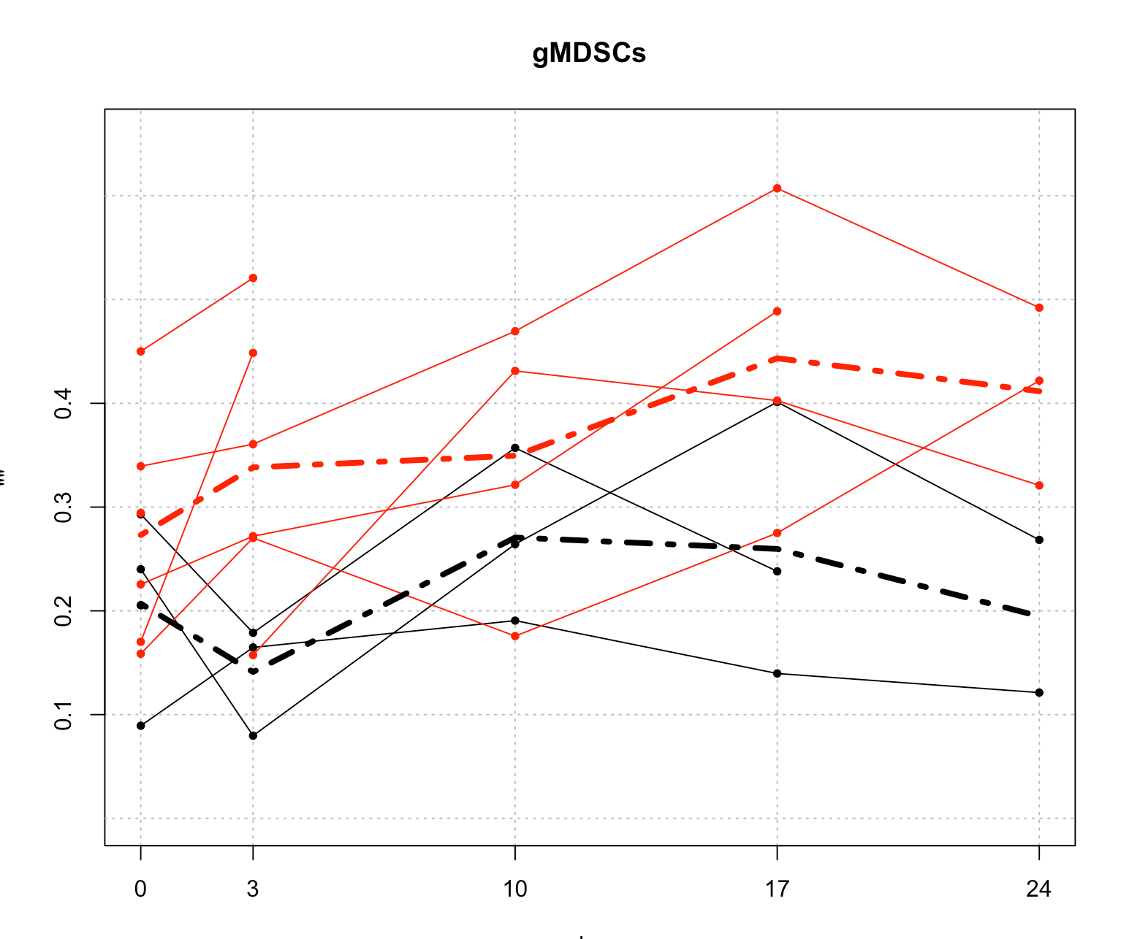

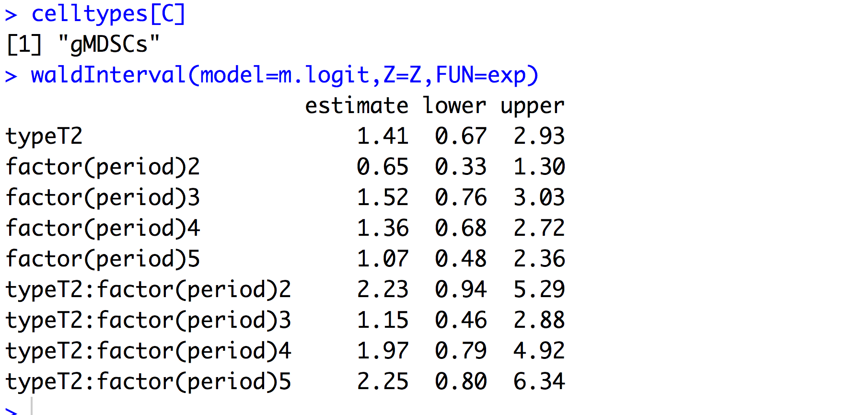

No differences at all.

## intMDSCs

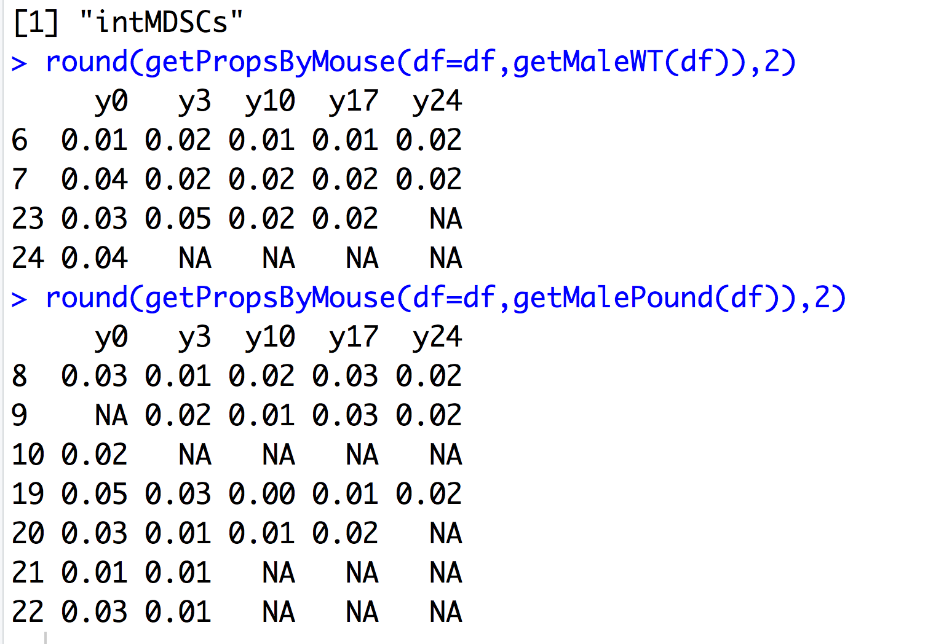

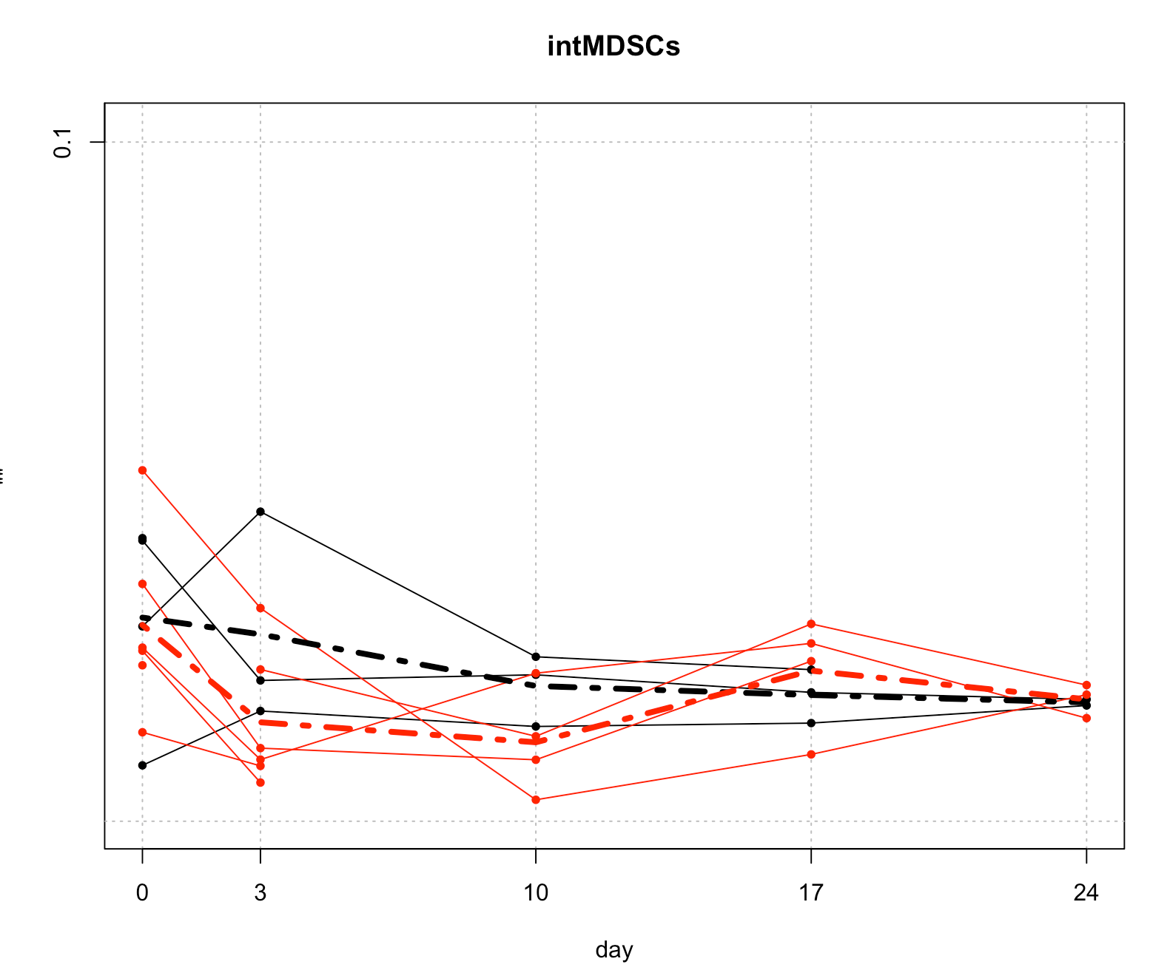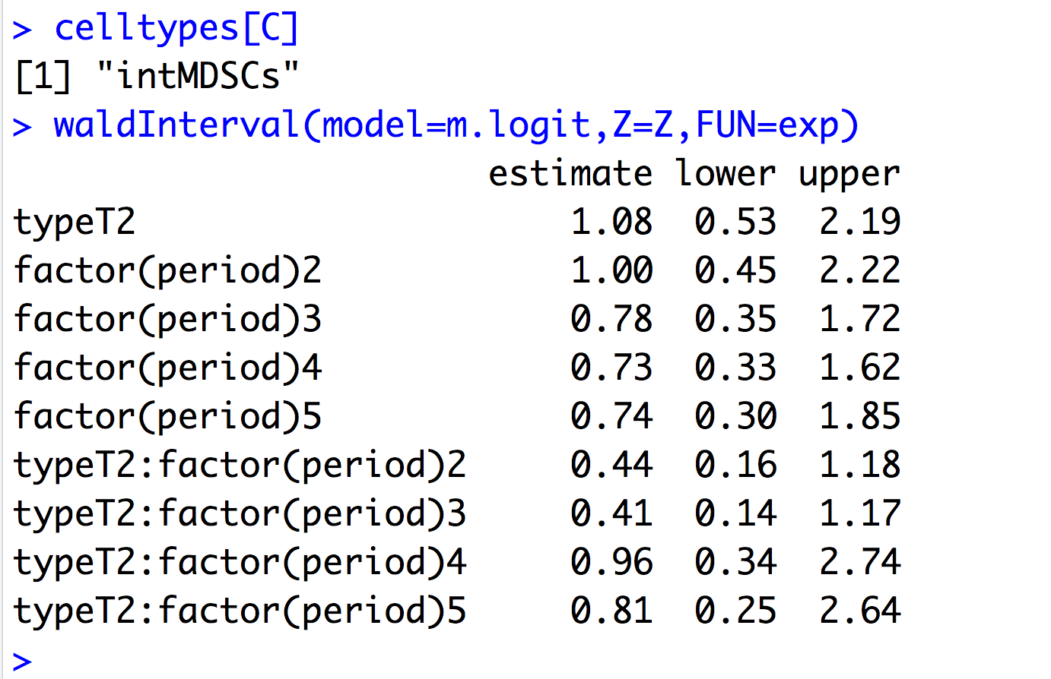

nothing is significant.